**Channon Harper  
s3871491**<https://github.com/Channon87/COSC2196-Assessment-1>  
<https://channon87.github.io/COSC2196-Assessment-1/>

## Personal information

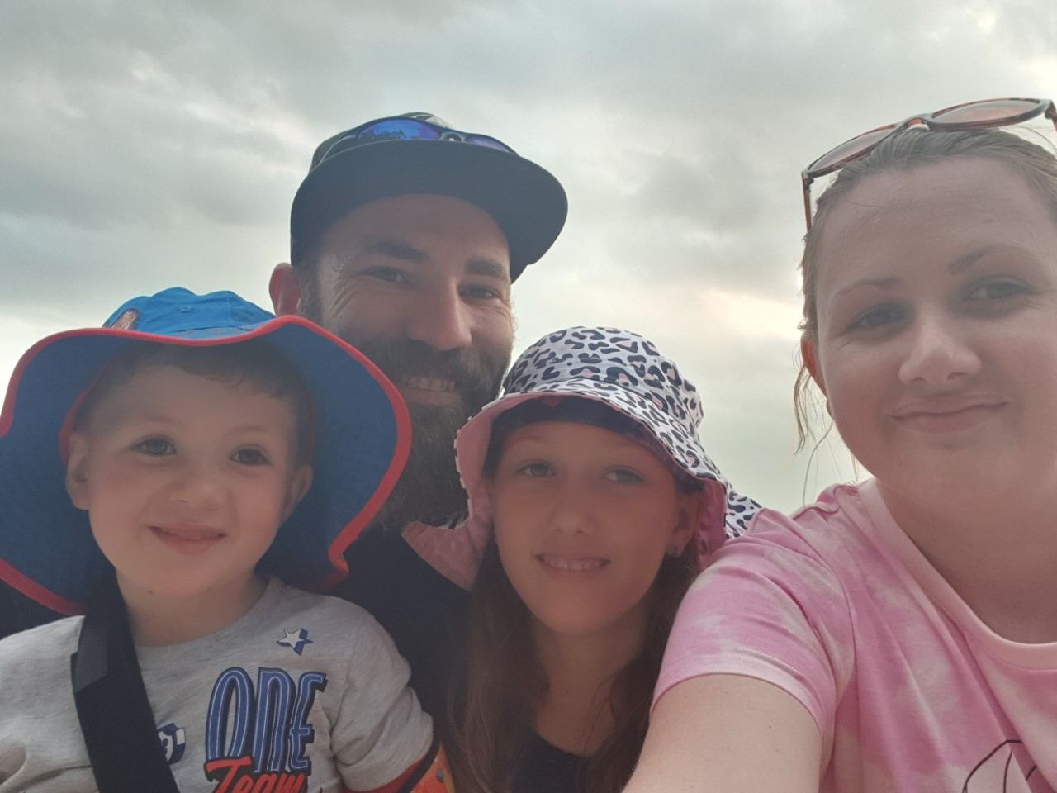

Hello, my name is Channon I do go by Harps so the pronunciation of my first name is not an issue I am currently 33 years old married with 2 children. I am an army child, so my childhood was spent travelling Australia and overseas. I was born in Victoria and currently reside in Queensland and have always wanted to return to Tonga someday. My current highest held education is a Cert III in plumbing and gas, I have no higher official recognized training but I do highly believe that one’s intelligence cannot be measured by a piece of paper however it does show capability in a certain field. An interesting fact about me is when I was younger, I was on track to play Professional AFL but was told I was too short mind you I am 1.81m.

Close

## Interests in IT

My interest in IT is to see where it can take us in the future, I have seen the progress through the years and the rate it progressing I want to jump on board. It all started for me when I was about 7 playing street fighter on the pc learning to put in the right codes in dos just to boot up the game. After that my love continued to grow mainly through gaming and at about the age of 14 I started pulling apart computers and rebuilding them, and making my own text based games and further on to RPG games with a development engine. The main drive behind my love of IT would have to be my father being an electrical engineer in the army he was and still is my hero. With no formal education in IT only what I have learnt myself through trial and error and learning guides the only experience I have is my own.

## Why I chose RMIT

Why RMIT, when I injured myself at work, I knew I had to change career paths and sooner the better, so my first point of call was looking to see what education was available to me. This took me to OUA and with a quick expression of interest on a smaller certificate they put me onto the Bachelor of IT provided through RMIT. I was worried that I did not qualify and if I was ready to take on this weight but with some looking into, I concluded that it was the right fit for me. Not being able to make some timeframes others request and with the comfort of 100% online learning I was sold. Back that up with the Tutoring and Teaching from world class staff how could I of made any other decision.

## My expectations

In the next 3 years I hope to learn all the aspects surrounded in IT and where we are heading in the future. From the basics needed to the expert stages to further my knowledge and make myself an asset in this field is my main drive. To be able to help with simple IT problems to being on the forefront of development for the next big thing I expect my time spent here will get me moving in the right direction to where I want to be in the future. I also expect I will learn a lot about the community and how to keep in touch with future progress that is happening before it hits. Having fun and learning new things is what it is all about furthering knowledge is bettering one’s self.

Close

## My Ideal Job

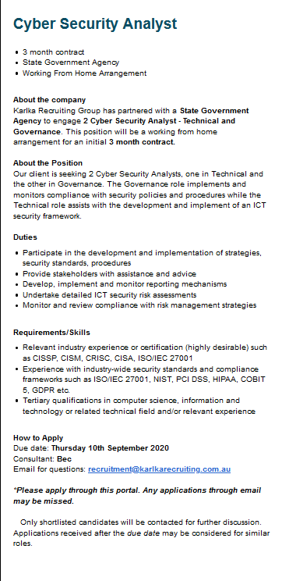

## [Cyber Security Analyst](https://www.seek.com.au/job/50508340?type=standard#searchRequestToken=17f84936-62f3-4378-964a-f310f00d5a72)

The position of cyber security analyst is to find vulnerabilities and exploits in IT infrastructure. To protect from any cyber-attacks that are occurring or may occur in the future to stay ahead of the hackers and implement fixes to prevent any intrusion. It is appealing to me because it can be completed working from home and with the inability for myself to join the police force this is one way I can stop criminals, cyber-crime is only increasing and I hate to see people lose finances or personal information to those that would do harm.

The skills and qualification required for this would be knowledge in industry-wide security standards, to obtain a bachelor’s in computer science/IT at a minimum, and to get a further certification on top of that to further grasp the knowledge needed and to increase prospects of getting a role in this position.

I currently have no skills viable for this job, so my outlay of how I will get this position in the future will be to complete the Bachelor of IT I am enrolled in. During this time, I hope to pick up an entry level job halfway through where I can make introductions and plant myself into the IT world. I will also be enrolling in a certification course starting from CompTIA security+ and CEH and then obtain the highest certification available at that time.

Close

## Personal Profile

I believe the results from the above tests are fairly accurate to how I perceive myself. The results of them do influence my behavior in a team I do know where I will sit, being very introverted I do like working by myself but in a group activity there is always a way to still work by yourself in a sense to give back to the group. I think the biggest downfall to my personality would have to be I may brush off other’s opinions and theories since I will not be able to see the logic behind it. When forming a group, I will consider my personality you can still be anti-social and have good input into a group perspective. Although they do some up who I am as a person I also believe in being like water and molding to a situation when it is needed.

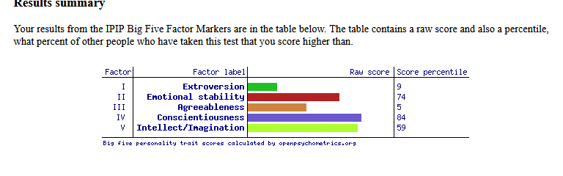

Openpsychometrics.org. 2020. Take A Personality Test - Open Source Psychometrics Project. [online] Available at: [Accessed 10 September 2020].

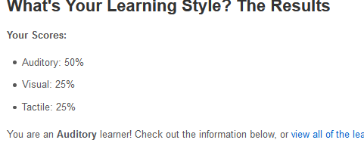

Educationplanner.org. 2020. What's Your Learning Style? 20 Questions. [online] Available at: [Accessed 10 September 2020]

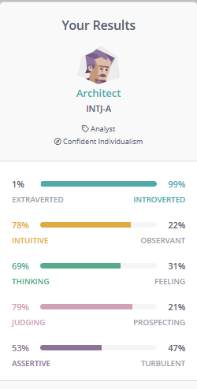

16Personalities. 2020. Free Personality Test | 16Personalities. [online] Available at: [Accessed 10 September 2020].

Close

## Project Idea

## Overview

My project idea is a tracking software for marine craft that would be used on multiple devices and make travelling offshore as safe as it possibly can be. It will include ship tracking, weather tracking, fuel tracking, tides amongst others. For the smaller class vessels even personal boats I want it to achieve the fundamentals merging many elements into 1 app. It relies on data transfer and with the current networking could be used approx. 15km out to sea. With minor features built in it should be a one stop shop to all sea goers.

## Motivation

Having always fished myself I believe even in its baby state it can help a lot; my motivation does not come from statistics but rather a personal experience. With fisherman and main vessels being capsized and sailors not returning home to loved ones making the task of leaving land should be made safer by any means available. I am unsure of the technology available for higher-class vessels but for the average Joe Blow there are items and tech available but the excessive costs make it not feasible to have what you need to be as safe as you can be.

## Description

For the initial project development of the ‘Sailor’s Overwatch’ would be created it will have the following features,  
  
Major Features  
  
• GPS tracking- this is a given and the app itself cannot work without it will feature its own standalone tracking inputs. Also, will feedback other vessels in the area surrounding using the app. It will have a start point and plot the coarse you have taken so you can follow it home, save it to take the same path again, or to be sent off in the SOS feature.  
  
• Weather tracking – it will use the most reliable data given in real time from BOM for your current location giving warning and abilities to track storm clusters that can effectively cross your path. Will also output high winds so you can know if the seas will become choppy and become unsafe.  
  
• Trip tracking – before heading out a trip plan will be made and further data in the app will be amend the trip to suite what is possible, it also will send data off to nearest services in case of emergency.  
  
• Tide tracking – necessity to plan the trip and will give warning of high tide windows to safely return home. And will work in turn with the ocean floor outlay to show when it is safe to pass certain areas.  
  
• Fuel tracking – with an equation principal the user can enter fuel stores and motors and will feed back with safety values how far out you can go and when you need to turn back.  
  
• SOS – flares are good and all but in the event you find yourself in dire need you can send out an emergency text or signal to nearest vessels and to shore, With all data stored in one app can make it a lot easier to pinpoint exactly where you and can be rescued sooner.  
  
• Ocean floor level – Gives a visual output of the ocean floor where deep water is, and reefs are located.  
  
Minor Features  
  
• Fish locations- users can input data that can be shared amongst others of when and where they came across of school of fish and what fish they were. The option to not share is also available and can plot them for yourself. This can be used for fishermen and marine biologists alike.  
  
• Water temperatures – important for being able to track fish this is a further elaboration on the weather app but will track high and lows and give expected water temps on previous days of weather.  
  
• Fish identification - A scanner to identify caught fish to know limitations of catching.  
  
• Season fish tracking – at the press of a button it can output to main map where you can expect to find sought after fish at the expected time of year you are at.  
  
• Social network – a message board where you can post trips and network together to get partners on your fishing trip or just share general information.  
  
All these will work over internet and phone signals so will not be suitable for long range trips without satellite or booster.

## Tools and Technologies

This being an app will work on most smart phones, has also the possibility to be integrated into some on board computer system such as a sounder with limited features. Will also require the need to have a hardware that has GPS available and with its limited ranging an onboard signal booster would be highly desirable. The development of this will require a software writing program such as Xcode and Swift to become platform compatible. It could also use many other coding programs to enter the required data needed.

## Skills Required

The skills needed to complete this project would be firstly a software engineer, you need to be able to turn ideas into a working product. Given that some of what is in this app exists (weatherzone, findmyphone) I know it is doable, to write them all together in 1 package is yet to be done. Would also need to be marketed because some of the features rely on data input from users themselves in its early stages may not work to its given potential. A lot of data will be needed to be input so finding reliable sourcing may also be an issue. Completing my full coarse of Bachelor in IT will give me the majority of the skills required to make this Idea marketable.

## Potential Outcome

If this project was to come to light and worked as intended foremost the safety whilst out on the water would improve dramatically, having it available to everyone would make it more streamline and sea goers would be able to try it without forking out heaps of money. This developments impact could be limitless more understanding of the ocean could be achieved, it may even be used in different scenarios in the future (hiking ,hunting) with the possibility of having them on larger ships to be tracked just as planes are with a built in black box.

Close